Contextualizing Instruction in IELCE Activities
Participant Activity Guide

Table of Contents

Introduction 3
Agenda 3
Activity 1: What Does The Word “Integrated” Mean In IELCE? 4
Group Discussion 1: Understanding Contextualized Instruction 5
Group Discussion 2: Understanding Contextualized Instruction 6
Activity 2: Using The Contextual Model Of Instruction In An IELCE Classroom 7
Activity 3: Identify Key Elements Of The Contextualized Model Of Instruction 8
Group Discussion 3: Understanding Contextualized Instruction 9
Activity 4: Create An Integrated Learning Objective For A Sample IELCE Program 10
Drug Administration - Decision Tree 11
Activity 5: Adapt Or Start From Scratch? 12
Group Discussion 4: Understanding Contextualized Instruction 14
References 15
More Resources 16

Introduction
Integrated English Literacy and Civics Education (IELCE) activities are a main pathway to support immigrants’ civic, linguistic, and economic integration in U.S. society. For this reason, IELCE activities aim to assist immigrants and English language learners in their roles as parents, workers, and citizens through integrated civics and English language literacy acquisition instruction and as conveyed in Workforce Innovation and Opportunity Act (WIOA) Sec. 243, IELCE, workforce preparation, and workforce training.
Contextualized instruction is for language learners living in a new country; a language can be both an academic subject to be studied and a life skill to acquire. Contextualized instruction, including civics- and workplace-specific content, is relevant to the everyday survival and success of English learners.
This training will focus on developing contextualized instruction that integrates developing English language skills within the context of an occupational training and civics education rather than teaching them abstractly or discretely so that they have meaning and applicability for the adult learner.
As a result, learners will be able apply their newly acquired English language skills to fit into concrete life and work situations. Contextualizing English language instruction with civics and occupational instruction is particularly useful when delivering instructional in IELCE / Integrated Education and Training (IET) activities.

Agenda
- Introduction to Contextualized Instruction | - Overcoming Challenges to Contextualizing Instruction for IELCE Activities
- Understanding Contextualized Instruction
- Building Contextualization Lessons for Integrated English Literacy and Civics Education (IELCE) Activities | - Wrap-Up

Activity 1: What does the word “integrated” mean in IELCE?
Activity Instructions: Come up with a definition for “integrated” in your own words. Each group will share their answers with the larger group, as time allows.
________________________________________________________________________________________________________________________________________________________________________________________________________________________________________________________________________________________________________________________________________________________________________________________________________________________________________________________________________________________________________________________________________________________________________________________________________________________________________________________________________________________________________________________________________________________________________________________________________________________________________________________________________________________________________________________________________________________________________________________________________________________________________________________________________________________________________________________________________________________________________________________________________________________________________________________________________________________________________________________________________________________________________________________________________________________________________________________________________________________________________________________________________________________________________________________________________________________________________________________________________________________________________________________________________________________________________________________________________________________________________________________________________________________________________________________________________________________________________________________________________________________________________________________________________________________________________________________________________________________________________________________________________________________________________________________________________________________________________________________________________________________________________________________________________________________________________________________________________________________________________________________________________________________________________________________________________________________________________________________________________________________________________________________________________________________________________________________________________________________________________________________________________________________________________________________________________________________________________________________________________________________________________________________________________________________________________________________________________________________________________________________________________________________________________________________________________________________________________________________________________________________________________________________________________________________________________________________________________________________________________________________________________________________________________________________________________________________________________________________________________________________________________________________________________________________________________________________________________________________________

Group Discussion 1: Understanding Contextualized Instruction
Q. What is contextualized instruction?
________________________________________________________________________________________________________________________________________________________________________________________________________________________________________________________________________________________________________________________________________________________________________________________________________________________________________________________________________________________________________________________________________________________________________________________________________________________________________________________________________________________________________________________________________________________________________________________________________________________________________________________________________________________________________________________________________________________________________________________________________________________________________________________________________________________________________________________________________________________________________________________________________________________________________________________________________________________________________________________________________________________________________________________________________________________________________________________________________________________________________________________________________________________________________________________________________________________________________________________________________________________________________________________________________________________________________________________________________________________________________________________________________________________________________________________________________________________________________________________________________________________________________________________________________________________________________________________________________________________________________________________________________________________________________________________________________________________________________________________________________________________________________________________________________________________________________________________________________________________________________________________________________________________________________________________________________________________________________________________________________________________________________________________________________________________________________________________________________________________________________________________________________________________________________________________________________________________________________________________________________________________________________________________________________________________________________________________________________________________________________________________________________________________________________________________________________________________________________________________________________________________________________________________________________________________________________________________________________________________________________________________________________________________________________________________________________________________________________________________________________________________________________________________________________________________________________________________________________________________________
Q. What is contextualized instruction within IELCE activities and programs?
________________________________________________________________________________________________________________________________________________________________________________________________________________________________________________________________________________________________________________________________________________________________________________________________________________________________________________________________________________________________________________________________________________________________________________________________________________________________________________________________________________________________________________________________________________________________________________________________________________________________________________________________________________________________________________________________________________________________________________________________________________________________________________________________________________________________________________________________________________________________________________________________________________________________________________________________________________________________________________________________________________________________________________________________________________________________________________________________________________________________________________________________________________________________________________________________________________________________________________________________________________________________________________________________________________________________________________________________________________________________________________________________________________________________________________________________________________________________________________________________________________________________________________________________________________________________________________________________________________________________________________________________________________________________________________________________________________________________________________________________________________________________________________________________________________________________________________________________________________________________________________________________________________________________________________________________________________________________________________________________________________________________________________________________________________________________________________________________________________________________________________________________________________________________________________________________________________________________________________________________________________________________________________________________________________________________________________________________________________________________________________________________________________________________________________________________________________________________________________________________________________________________________________________________________________________________________________________________________________________________________________________________________________________________________________________________________________________________________________________________________________________________________________________________________________________________________________________________________________________________

Group Discussion 2: Understanding Contextualized Instruction
Q. How does contextualized instruction support these principles?
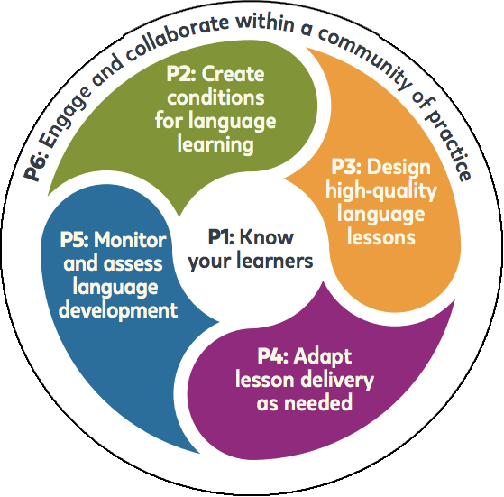________________________________________________________________________________________________________________________________________________________________________________________________________________________________________________________________________________________________________________________________________________________________________________________________________________________________________________________________________________________________________________________________________________________________________________________________________________________________________________________________________________________________________________________________________________________________________________________________________________________________________________________________________________________________________________________________________________________________________________________________________________________________________________________________________________________________________________________________________________________________________________________________________________________________________________________________________________________________________________________________________________________________________________________________________________________________________________________________________________________________________________________________________________________________________________________________________________________________________________________________________________________________________________________________________________________________________________________________________________________________________________________________________________________________________________________________________________________________________________________________________________________________________________________________________________________________________________________________________________________________________________________________________________________________________________________________________________________________________________________________________________________________________________________________________________________________________________________________________________________________________________________________________________________________________________________________________________________________________________________________________________________________________________________________________________________________________________________________________________________________________________________________________________________________________________________________________________________________________________________________________________________________________________________________________________________________________________________________________________________________________________________________________________________________________________________________________________________________________________________________________________________________________________________________________________________________________________________________________________________________________________________________________________________________________________________________________________________________________________________________________________________________________________________________________________________________________________________________________________________________

Activity 2: Using the Contextual Model of Instruction in an IELCE Classroom
Activity Instructions: Complete activity based on the video presented. Use the below tic-tac-toe grid to predict some key concepts that you’ll hear about in the video. Let’s see if you can get three in a row.
________________________________________________________________________________________________________________________________________________________________________________________________________________________________________________________________________________________________________________________________________________________________________________________________________________________________________________________________________________________________________________________________________________________________________________________________________________________________________________________________________________________________________________________________________________________________________________________________________________________________________________________________________________________________________________________________________________________________________________________________________________________________________________________________________________________________________________________________________________________________________________________________________________________________________________________________________________________________________________________________________________________________________________________________________________________________________________________________________________________________________________________________________________________________________________________________________________________________________________________________________________________________________________________________________________________________________________________________________________________________________________________________________________________________________________________________________________________________________________________________________________________________________________________________________________________________________________________________________________________________________________________________________________________________________________________________________________________________________________________________________________________________________________________________________________________________________________________________________________________________________________________________________________________________________________________________________________________________________________________________________________________________________________________________________________________________________________________________________________________________________________________________________________________________________________________________________________________________________________________________________________________________________________________________________________________________________________________________________________________________________________________________________________________________________________________________________________________________________________________________________________________________________________________________________________________________________________________________________________________________________________________________________________________________________________________________________________________________________________________________________________________________________________________________________________________________________________________________________________________________

Identify Key Elements of the Contextualized Model of Instruction
Case Study
Instructions: Within this case study, find illustrations of these key elements:
- Purpose—Learners find, develop, and apply knowledge to real life, work, civic engagement, and rights and responsibilities of citizens.
- Organization—English language and classroom content connected to the community and patterned after the workplace or civic engagement and rights and responsibilities of citizens.
- Role of Instructor—Facilitator/coordinator; a knowledgeable guide to finding, developing, and applying knowledge.
- Role of Learner—Active engagement in constructive learning through workplace- or civics-relevant activities and content.
- Content—Subject application tailored for different proficiency levels.
- Method-Inquiry, discovery, applied learning and methods.

Lesson Topic: Reading an Employee Schedule (Intermediate)
- Activating Prior Knowledge/Preparing for Lesson
- Do you work? Does someone in your family work?
- Have you worked in the United States? In your home country?
- Tailor these questions to your audience based on the individuals: Do you already know that Abdullah’s son is a waiter? Do you already know that Thao works at a salon?
- Introducing Vocabulary
Key vocabularies are presented on the board/projection (see bullets below). The teacher says words aloud and students repeat. Which words do you know already? Let’s mark the ones we know. Students identify and teacher highlights/underlines the words identified as known by some students; this also allows students to recognize words they know by sound rather than reading. Teacher notes unknown words for expansion during the next steps. Advanced: students also offer brief definitions of the words.
Vocabulary and Key Ideas for Reading an Employee Schedule
- Days of the week and common abbreviations
Expansion and Follow-Up Topic
Speaking about time. There is a wide spectrum of time language that can be introduced, depending on learners’ levels (e.g., eleven-thirty, five-fifteen, quarter till ten, almost noon, about three)
- Times (Do your students employers use 12-hour or 24-hour clock times on schedules? Tailor to students.)
- Hours, schedule, shift, wage, rate, full/part-time, employee, employer
- From/to, from/until
- Get off work, clock in/out, have ____ off, day off
- , and – (meanings of commas and hyphen in times/days)

- Modeling
The teacher displays a simple schedule and talks about the employee’s work hours, as displayed. If some students have the same employer, possibly mimic the format of that employer’s schedule. Pilar works three days this week. Pilar works part-time. Pilar works from 8:00 to 4:00 on Thursday, Friday, and Saturday. The teacher also asks some prepared guiding questions to lead students to analyze the schedule. Which times do you think are AM and PM? Why? How many hours is Maria working this week?
Hilltop Café - Schedule for May 1-5, 2023
Maria Perez | Mon–Thurs | 9:00–5:00
Kara Williamson | Tues, Wed, Sat | 9:00–4:00
Pilar Martinez | Thurs–Sat | 8:00–4:00
Michael Griffith | Mon, Thurs | 10:30–5:00
Linh Nguyen | Mon–Sat | 8:30–12:00

Activity 1
Expansion and Follow-Up Topic
Teacher adds incidental vocabulary to Word Wall or asks students to include in vocabulary notebook.
Students are separated into small groups of about three people and given a simple employee schedule. The small groups practice talking about the schedule, and the teacher circulates and supports them as needed. The teacher tells the group to prepare to explain the work hours of one person on their schedule. Each group has a different simple schedule. The teacher notes vocabulary and structures that are the most challenging for reinforcement in next steps. The teacher asks guiding questions, as appropriate (e.g., Did you say from or at? Is this employee full-time or part-time? How do you know?)
Expansion and Follow-Up Topic
- Why do some employers like to hire many people for part-time work instead of full-time work?
- Do you know any laws about wages?

Activity 2
The teacher asks each group to briefly report the work hours of one person on their example schedule and gives support as appropriate, noting errors and challenges for her own use for follow-up and review in the lesson.
Expansion and Follow-Up Topic
Provide support for classroom talk, especially for new learners. Lessons or classroom materials should prepare students explicitly for classroom communication.
For example, Can you repeat that? Can you give more examples? What is the correct answer? What page are we on?

Activity 3
Step 1—In the same small groups, students are given blank schedules to fill in. Each student fills in an example schedule into their blank schedule.
Step 2—Students get an additional copy of the blank schedule. One student describes or dictates their example work schedule and the other students fill in the blank schedule. If appropriate for your students, consider seating students back-to-back to increase the amount of verbal communication necessary to accomplish the task. While working, students communicate with clarifying questions (e.g., Did you say Tuesday? What time does he start? 7:00 PM—is that correct?). The teacher supports as appropriate and provides additional instruction.

Activity 3: Identify Key Elements of the Contextualized Model of Instruction
Activity Instructions: In your group, review the case study in which an IELCE teacher uses the contextualized model of instruction and identify key elements of the model.
________________________________________________________________________________________________________________________________________________________________________________________________________________________________________________________________________________________________________________________________________________________________________________________________________________________________________________________________________________________________________________________________________________________________________________________________________________________________________________________________________________________________________________________________________________________________________________________________________________________________________________________________________________________________________________________________________________________________________________________________________________________________________________________________________________________________________________________________________________________________________________________________________________________________________________________________________________________________________________________________________________________________________________________________________________________________________________________________________________________________________________________________________________________________________________________________________________________________________________________________________________________________________________________________________________________________________________________________________________________________________________________________________________________________________________________________________________________________________________________________________________________________________________________________________________________________________________________________________________________________________________________________________________________________________________________________________________________________________________________________________________________________________________________________________________________________________________________________________________________________________________________________________________________________________________________________________________________________________________________________________________________________________________________________________________________________________________________________________________________________________________________________________________________________________________________________________________________________________________________________________________________________________________________________________________________________________________________________________________________________________________________________________________________________________________________________________________________________________________________________________________________________________________________________________________________________________________________________________________________________________________________________________________________________________________________________________________________________________________________________________________________________________________________________________________________________________________________________________________________________

Group Discussion 3: Understanding Contextualized Instruction
Q. What are some additional benefits of contextualized instruction?
________________________________________________________________________________________________________________________________________________________________________________________________________________________________________________________________________________________________________________________________________________________________________________________________________________________________________________________________________________________________________________________________________________________________________________________________________________________________________________________________________________________________________________________________________________________________________________________________________________________________________________________________________________________________________________________________________________________________________________________________________________________________________________________________________________________________________________________________________________________________________________________________________________________________________________________________________________________________________________________________________________________________________________________________________________________________________________________________________________________________________________________________________________________________________________________________________________________________________________________________________________________________________________________________________________________________________________________________________________________________________________________________________________________________________________________________________________________________________________________________________________________________________________________________________________________________________________________________________________________________________________________________________________________________________________________________________________________________________________________________________________________________________________________________________________________________________________________________________________________________________________________________________________________________________________________________________________________________________________________________________________________________________________________________________________________________________________________________________________________________________________________________________________________________________________________________________________________________________________________________________________________________________________________________________________________________________________________________________________________________________________________________________________________________________________________________________________________________________________________________________________________________________________________________________________________________________________________________________________________________________________________________________________________________________________________________________________________________________________________________________________________________________________________________________________________________________________________________________________________________

Activity 4: Create an Integrated Learning Objective for a Sample IELCE Program
Activity Instructions: In your group, create at least one performance-based, integrated learning objective that includes:
- Conditions under which the learner will demonstrate competency
- Behavior the learner will perform (using action verbs)
- Criteria by which competency will be measured
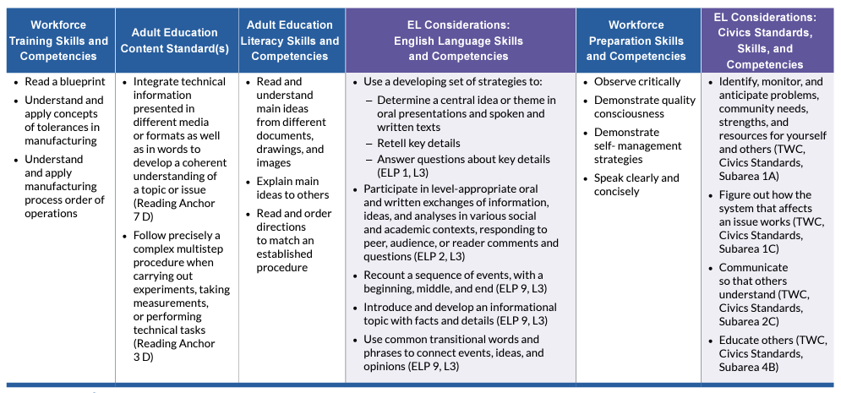
____________________________________________________________________________________________________________________________________________________________________________________________________________________________________________________________________________________________________________________________________________________________________________________________________________________________________________________________________________________________________________________________________________________________________________________________________________________________________________________________________

Brainstorm Contextualized Activities
________________________________________________________________________________________________________________________________________________________________________________________________________________________________________________________________________________________________________________________________________________________________________________________________________________________________________________________________________________________________________________________________________________________________________________________________________________________________________________________________________________________________________________________________________________________________________________________________________________________________________________________________________________________________________________________________________________________________________________________________________________________________________________________________________________________________________________________________________________

Drug Administration—Decision Tree
Q. Now that you’ve seen some examples, for this decision tree, what additional supplemental supports would you add?

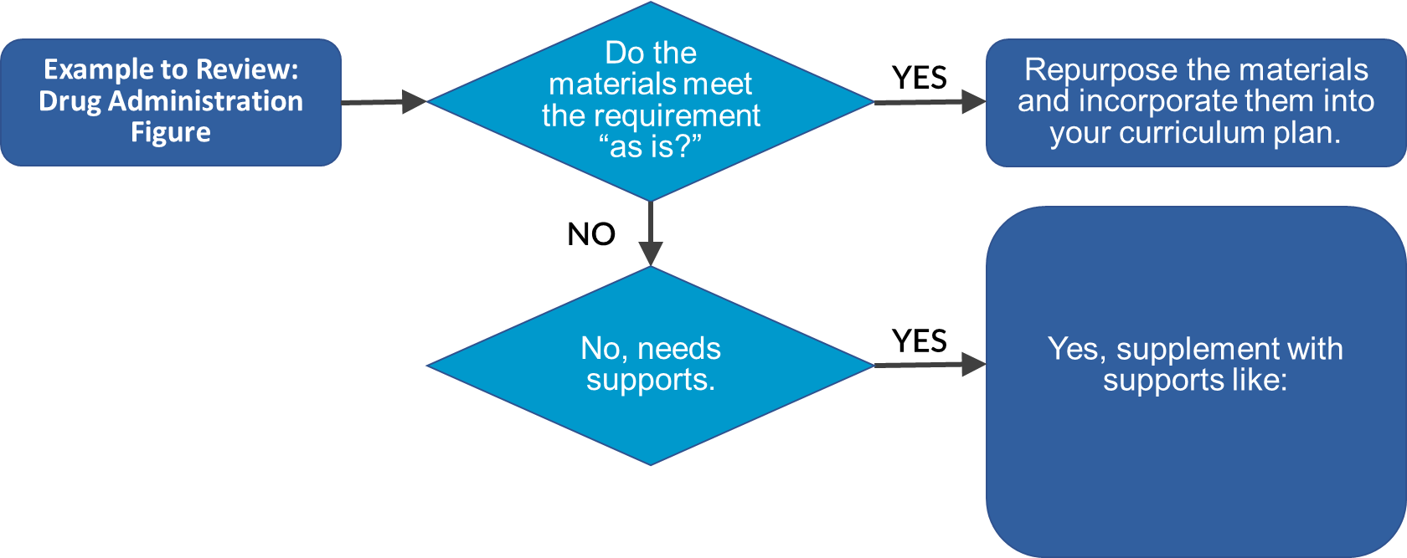
________________________________________________________________________________________________________________________________________________________________________________________________________________________________________________________________________________________________________________________________________________________________________________________________________________________________________________________________________________________________________________________________________________________________________________________________________________________________________________________________________________________________________________________________________________________________________________________________________________________________________________________________________________________________________________________________________________________________________________________________________________________________________________________________________________________________________________________________________________________________________________________________________________________________________________________________________________________________________________________________________________________________________________________________________________________________________________________________________________________________________________________________________________________________________________________________________________________________________________________________________________________________________________________________________________________________________________________________________________________________________________________________________________________________________________________________________________________________________________________________________________________________________________________________________________________________________________________________________________________________________________________________________________________________________________________________________________________________________________________________________________________________________________________________________________________________________________________________________________________________________________________________________________________________________________________________________________________________________________________________________________________________________________________________________________________________________________________________________________________________________________________________________________________________________________________________________________________________________________________________________________________________________________________________________________________________________________________________________________________________________________________________________________________________________________________________________________________________________________________________________________________________________________________________________________________________________________________________________________________________________________________________________________________________________________________________________________________________________________________________________________________________________________________________________________________________________________________________________________________________

Group Discussion 4: Understanding Contextualized Instruction
Scenario: Your IELCE will prepare learners for jobs in a local hospital system. Students in your program have work experience, but not in health occupations settings. This field is new to you as an instructor. Other programs in your area collaborate with this hospital. The digital literacy of the students varies.
Q. What challenges are encountered? What strategies can be used to overcome these challenges?
____________________________________________________________________________________________________________________________________________________________________________________________________________________________________________________________________________________________________________________________________________________________________________________________________________________________________________________________________________________________________________________________________________________________________________________________________________________________________________________________________________________________________________________________________________________________________________________________________________________________________________________________________________________________________________________________________________________________________________________________________________________________________________________________________________________________________________________________________________________________________________________________________________________________________________________________________________________________________________________________________________________________________________________________________________________________________________________________________________________________________________________________________________________________________________________________________________________________________________________________________________________________________________________________________________________________________________________________________________________________________________________________________________________________________________________________________________________________________________________________________________________________________________________________________________________________________________________________________________________________________________________________________________________________________________________________________________________________________________________________________________________________________________________________________________________________________________________________________________________________________________________________________________________________________________________________________________________________________________________________________________________________________________________________________________________________________________________________________________________________________________________________________________________________________________________________________________________________________________________________________________________________________________________________________________________________________________________________________________________________________________________________________________________________________________________________________________________________________________________________________________________

References
- Fundamental Principles of Effective English Language Education. https://www.cal.org/adultesl/resources/fundamental-principles.php
- National Research Council. 2012. Improving Adult Literacy Instruction: Supporting Learning and Motivation. Washington, DC: The National Academies Press. https://doi.org/10.17226/13469.
- TESOL. The 6 Principles for Exemplary Teaching of English Learners. https://www.tesol.org/the-6-principles/about
- U.S. Department of Education, Office of Career, Technical and Adult Education. Adult English Language Proficiency Standards for Adult Education. Washington, DC, 2016. https://lincs.ed.gov/publications/pdf/elp-standards-adult-ed.pdf
- U.S. Department of Education, Office of Career, Technical, and Adult Education, Integrated Education and Training (IET) Design Toolkit. Washington, DC, 2022.
https://lincs.ed.gov/sites/default/files/2023-01/IET-Toolkit.pdf
- U.S. Department of Education, Office of Career, Technical and Adult Education. Observing, Analyzing, and Developing Problem-Based Learning in Action. https://lincs.ed.gov/sites/default/files/ObsAnalDevPrbBsdLrnActn-508.pdf
- U.S. Department of Education, Office of Career, Technical and Adult Education. Observing, Analyzing, and Developing Integrated Contextualized Learning in Action. https://lincs.ed.gov/sites/default/files/ObsAnalDevIntContLrnActn-508.pdf
- U.S. Department of Education, Office of Career, Technical and Adult Education. Civics Brief. https://lincs.ed.gov/sites/default/files/TSTMCivEducationBrief-508.pdf

More Resources
- Bureau of International Labor Affairs | What are Workers Rights? https://www.dol.gov/agencies/ilab/our-work/workers-rights
- Teaching Skills That Matter (TSTM) | Observing, Analyzing, and Developing Problem-Based Learning in Action
https://lincs.ed.gov/sites/default/files/ObsAnalDevPrbBsdLrnActn-508.pdf
- Meeting the Language Needs of Today’s Adult English Language Learner: Issue Brief
https://lincs.ed.gov/sites/default/files/ELL_Increasing_Rigor_508.pdf
- The Communicative Language Approach in ESL Education
https://online.ulm.edu/degrees/education/med/curriculum-and-instruction/communicative-language-approach/
- English Language Proficiency Standards for Adult Education | LINCS
https://lincs.ed.gov/publications/pdf/elp-standards-adult-ed.pdf
- Teaching Skills that Matter Civics Education | LINCS
https://lincs.ed.gov/state-resources/federal-initiatives/teaching-skills-matter-adult-education/civics-education
- Microsoft | Get your document's readability and level statistics
https://support.microsoft.com/en-us/office/get-your-document-s-readability-and-level-statistics-85b4969e-e80a-4777-8dd3-f7fc3c8b3fd2
- Readable.com
https://app.readable.com/text/
- Readability Analyzer
https://datayze.com/readability-analyzer

